# 6733 Team2 CATS SPRINT 1 Gamming Matchmaker Project Test Coverage

Main REPO : <https://github.com/sloanlipman/ksu-swe-6733-gaming-matchmaker>

These files are in the OneDrive Repo:

<https://kennesawedu-my.sharepoint.com/:f:/r/personal/sherchen_students_kennesaw_edu/Documents/6733Team2CATS?csf=1&e=ZkthNI>

# MAIN COVERAGE FILE

## FILE: index.html

# All files

**91.58%** Statements 185/202

**86.11%** Branches 31/36

**84%** Functions 42/50

**90.96%** Lines 161/177

Press n or j to go to the next uncovered block, b, p or k for the previous block.

| **File** |  | **Statements** |  | **Branches** |  | **Functions** |  | **Lines** |  |
| --- | --- | --- | --- | --- | --- | --- | --- | --- | --- |
| src |  | 100% | 3/3 | 100% | 0/0 | 100% | 0/0 | 100% | 3/3 |
| src/app |  | 88.37% | 38/43 | 0% | 0/3 | 82.35% | 14/17 | 87.5% | 35/40 |
| src/app/pages/about |  | 100% | 4/4 | 100% | 0/0 | 100% | 1/1 | 100% | 3/3 |
| src/app/pages/contact-page |  | 100% | 4/4 | 100% | 0/0 | 100% | 1/1 | 100% | 3/3 |
| src/app/pages/edit-profile-page |  | 91.67% | 11/12 | 100% | 2/2 | 66.67% | 2/3 | 90% | 9/10 |
| src/app/pages/home-page |  | 92.86% | 13/14 | 100% | 2/2 | 100% | 3/3 | 91.67% | 11/12 |
| src/app/pages/landing-page |  | 100% | 9/9 | 100% | 2/2 | 100% | 1/1 | 100% | 7/7 |
| src/app/pages/login-page |  | 68.18% | 15/22 | 100% | 2/2 | 40% | 2/5 | 68.42% | 13/19 |
| src/app/pages/matchmake-view-page |  | 100% | 16/16 | 100% | 5/5 | 100% | 3/3 | 100% | 14/14 |
| src/app/pages/register-page |  | 100% | 10/10 | 100% | 2/2 | 100% | 2/2 | 100% | 8/8 |
| src/app/pages/view-profile-page |  | 100% | 12/12 | 100% | 2/2 | 100% | 2/2 | 100% | 10/10 |
| src/app/shared/components/about |  | 100% | 4/4 | 100% | 0/0 | 100% | 1/1 | 100% | 3/3 |
| src/app/shared/components/contact-page |  | 100% | 4/4 | 100% | 0/0 | 100% | 1/1 | 100% | 3/3 |
| src/app/shared/components/loading-indicator |  | 100% | 4/4 | 100% | 0/0 | 100% | 1/1 | 100% | 3/3 |
| src/app/shared/models |  | 100% | 9/9 | 100% | 14/14 | 100% | 2/2 | 100% | 9/9 |
| src/app/shared/services/login-service |  | 90.63% | 29/32 | 0% | 0/2 | 85.71% | 6/7 | 90% | 27/30 |

Code coverage generated by [istanbul](https://istanbul.js.org/) at Sun Mar 24 2019 15:28:27 GMT-0400 (Eastern Daylight Time)

## FILE: test.ts.html

# All files / src test.ts

**100%** Statements 3/3

**100%** Branches 0/0

**100%** Functions 0/0

**100%** Lines 3/3

Press n or j to go to the next uncovered block, b, p or k for the previous block.

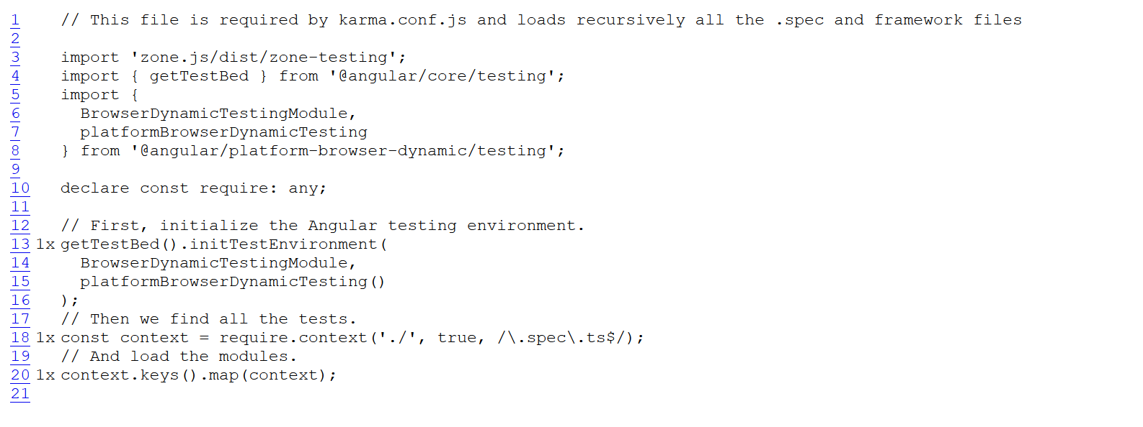

Code coverage generated by [istanbul](https://istanbul.js.org/) at Sun Mar 24 2019 15:28:27 GMT-0400 (Eastern Daylight Time)